**Introduction to AP U.S. Government and Politics**

AP U.S. Government and Politics is a college-level year-long course that not only seeks to prepare students for success on the AP Exam in May, but also provides students with the political knowledge and reasoning processes to participate meaningfully and thoughtfully in discussions and debates that are currently shaping American politics and society.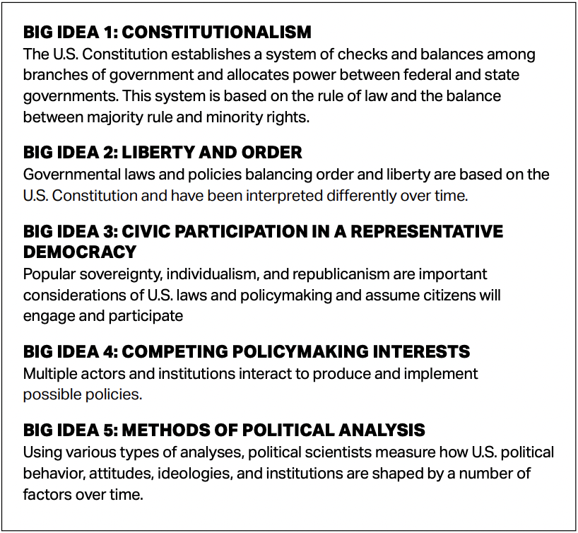

AP GoPo provides a college-level, nonpartisan introduction to key political concepts, ideas, institutions, policies, interactions, roles, and behaviors that characterize the constitutional system and political culture of the United States. In this course, we will study U.S. foundational documents, Supreme Court decisions, and other texts and visuals to understand the relationships and interactions among political institutions, processes, and behaviors. Underpinning the required content of the course are 5 Big Ideas that will allow you to create meaningful connections among concepts throughout the course. We will also engage in skill development that requires reading and interpreting data, making comparisons and applications, and developing evidence-based arguments. In addition, you will complete a political science research or applied civics project as part of your Fall Linked Learning Project.

It is important to note that this course is not a history course; it is a political science course that studies the interconnectedness of the different parts of the American political system and the behaviors and attitudes that shape it and are the byproducts of this system.

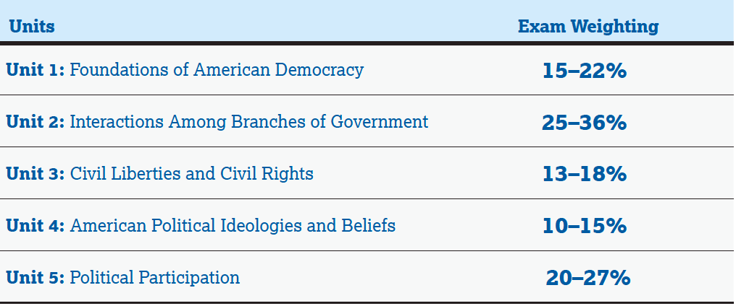

| Students enrolled in this course are  EXPECTED to take the AP Exam*  **AP US Government & Politics**  **Exam Date & Time**  Monday- May 6, 2024  Exam Begins at 8 AM  *\*Failure to take the exam will result in*  *1)a deduction of $40 from senior activities, and 2) an inability to receive an A in the course.* |
| --- |

**Instructional Schedule**

This AP U.S. Government and Politics class is taught in one year within an alternating block schedule. Each class period varies between 1 hour and 45 minutes to 48 min classes depending on the school schedule. There are 18 instructional weeks in the fall semester and 23 weeks in the spring semester.

**Overview of Required Course Texts and Additional Resources**

**Textbook and Online Resources**

Each student will check out a copy of the following textbook at the beginning of the course. Access to the digital version of the text is available through Schoology.

Harrison, B., Harris, J *American Democracy Now, 5th Ed.* New York: McGraw-Hill Education, 2016.

**Supplemental Readings**

The primary text will be heavily supplemented by outside readings, including the 15 required Supreme Court cases and nine foundational documents which will all be assigned during the course.

In addition to the required cases and documents, recent articles regarding political science concepts and current political issues will be provided to students to supplement the primary text. Links to the supplemental readings will be posted on the course website (Schoology) or provided to students in hard copy.

**Required Foundational Documents [CR10: foundational documents]**

This course will incorporate the analysis and discussion of nine required foundational documents to help understand the context and beliefs of the founders and their critics and the debates surrounding the writing and ratification of the U.S. Constitution:

* The Declaration of Independence
* The Articles of Confederation
* Federalist No. 10
* Brutus No. 1
* Federalist No. 51
* The Constitution of the United States
* Federalist No. 70
* Federalist No. 78
* “Letter from Birmingham Jail”

**Required Supreme Court Cases [CR15: Supreme Court cases]**

This course will incorporate the analysis of the following 15 required Supreme Court cases:

* Marbury v. Madison (1803)
* McCulloch v. Maryland (1819)
* Schenck v. United States (1919)
* Brown v. Board of Education (1954)
* Baker v. Carr (1961)
* Engel v. Vitale (1962)
* Gideon v. Wainwright (1963)
* Tinker v. Des Moines Independent Community School District (1969)
* New York Times Company v. United States (1971)
* Wisconsin v. Yoder (1972)
* Roe v. Wade (1973)
* Shaw v. Reno (1993)
* United States v. Lopez (1995)
* McDonald v. Chicago (2010)
* Citizens United v. Federal Election Commission (FEC) (2010)

For each of these cases, the facts, issues, holdings, and reasoning underlying the majority and dissenting opinions can be found through the Oyez database online. Oyez also has an app that can be downloaded to smartphones. Students will be required to complete multiple assignments analyzing and comparing these cases with other non-required cases.

**Required Materials**

* Spiral or Composition Notebook for Course Notes
* Binder or folder for handouts and supplemental readings
* Writing Instruments: pens, pencils, highlighters
* Laptop and Charger
* Headphones

**Overview of the AP Exam and the Key to AP Exam Success**

The AP U.S. Government and Politics Exam will be comprised of the following sections:

**Multiple-Choice Questions**

Number of Questions: 55

Timing: One hour and 20 minutes

Percentage of Total Exam: 50%

Structure – The questions on multiple choice will ask students to:

* Analyze and compare political concepts
* Analyze and interpret quantitative, text-based, and visual sources
* Apply course concepts, foundational documents, and Supreme Court decisions in a variety of hypothetical and real-world scenarios

**Free-Response Questions**:

Number of Questions: 4

Timing: One hour and 40 minutes

Percentage of Total Exam: 50%

Structure – The four questions on the free response will ask students to:

* Concept Application: Apply political concepts in real-world scenarios
* Compare the decisions and implications of different Supreme Court cases
* Analyze quantitative data
* Develop an argument using required foundational documents as evidence

As the breakdown of the AP Exam highlights, success in this course and on the AP Exam requires far more than the memorization of political knowledge. Success in this course and on the AP Exam requires connection-making with the aim of being able to analyze political information, regardless of the format the information is presented, and develop a factually accurate, thoughtful, and well-reasoned opinion regarding this information.

The different pieces of the course fit together in pursuit of this aim through course content and big ideas, and course skills.

**Course Skills**

This section presents the skills that students should develop during the AP U.S. Government and Politics course and that form the basis of the tasks on the AP Exam.

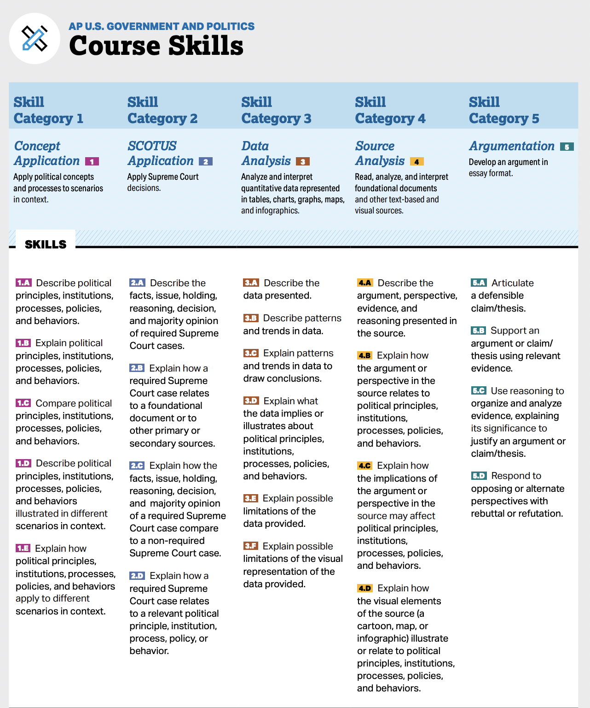

**Expectations of Students in AP Government:**

**AP Exam:** You are expected to take the AP Government exam in May.

**AP Classroom/ Readings:** Complete all assignments before class, take notes on the key concepts, prepare discussion questions, and be prepared to discuss what you’ve learned, are wondering, and/or are unclear about.

**Flipped Classroom Model**: This is an approach to learning where students are introduced to content independently and come to class ready to discuss what was learned or unclear. These materials will be available through Schoology, AP Classroom, and Khan Academy.

**Late Work:** Prior to each grading period, I will share a list of assignments that can still be turned in by a specific due date. Once the due date has passed and grades are submitted, those assignments will no longer be submitted. Assignments related to a larger project or assessment cannot be submitted after the project or assessment has been submitted since the purpose of the work is no longer relevant.

**Communication:** Open and honest communication is key. Please use the Remind App or Email to let me know if you will be absent, or have a need/concern regarding the course.

**Senior Contract and School Policies:** Students are expected to follow the guidelines agreed to in the Senior Contract. Please follow all school policies, including the cell phone use policy.

**Learning Environment:** Most importantly, this is a space to learn from our mistakes and accomplishments. In order to feel safe and comfortable as we tackle dense, complicated, potentially controversial, and upsetting material, it’s important that we accept where we are and who we are with so that everyone and their ideas are valued and heard. It’s ok to ask hard questions and to struggle. Be determined and know that you can grow in whatever skills or content you want as long as you work at it.

**Grading:** *AP Government is Equitable Grading & Instruction Aligned*

**Learning Targets & Grade Categories**

| **Learning Target (LT)** | **Grade Category** | **Weight** |
| --- | --- | --- |
| **LT1** | **Concept Application** | **10%** |
| **LT2** | **SCOTUS Application** | **10%** |
| **LT3** | **Data Analysis** | **10%** |
| **LT4** | **Source Analysis** | **10%** |
| **LT5** | **Argumentation** | **10%** |
| **Learning Target (LT)** | **Grade Category** | **Weight** |
| **LT6** | **Sustained Inquiry:** *Students can generate questions and apply research skills to discover possible solutions.* | **10%** |
| **LT7** | **Academic Discourse:** *Students engage in academic discourse with their peers to deepen their understanding of course concepts, make connections to readings, and think critically.* | **10%** |
| **LT8** | **Research to Present Information** | **10%** |
| **LT9** | **Content Understanding:** *Students are able to demonstrate their understanding of course concepts and Big Ideas.* | **10%** |
| **LT10** | **Work Habits: Notetaking** | **5%** |
| **LT11** | **Course Logistics** | **5%** |

**Course Proficiency Scale**

| **Mastery Category** | **Point = Grade** | **%** |
| --- | --- | --- |
| **Mastery (MA):** *The student demonstrates a complete and detailed understanding of the learning target.* | 4 = A | 100%  81% |
| **MA/ Prof** | 3.5 |  |
| **Proficient (Prof):** *The student demonstrates a considerable understanding of the learning target* | 3 = B | 80%-61% |
| **Prof/ Basic Prof** | 2.5 |  |
| **Basic Proficient (BP):** *The student demonstrates incomplete understanding of the learning target* | 2 = C | 60%-41% |
| **BP** | 1.5 |  |
| **Limited Proficient:** *The student demonstrates very little understanding, or has multiple misconceptions about the learning target* | 1 = D | 40%-21% |
| **No Evidence/ Not Yet Proficient** | 0 = Fail | 20%- 0% |

Mrs. Mora-Whitehead (she/her)

Preferred Name: Ms. Mora

emm9674@lausd.net

**AP Government & Politics: United States**

2023-2024 Course Outline

**AP GoPo Syllabus Acknowledgement**

By signing this acknowledgment sheet, you are verifying that you understand the expectations of the course, your participation, and engagement in class and with course materials, and you understand how you will be graded.

_____________________________ __________________________

Student First Last Name Student Signature

_____________________________ __________________________

Parent First Last Name Parent Signature

Parent Contact Information :______________________________________________